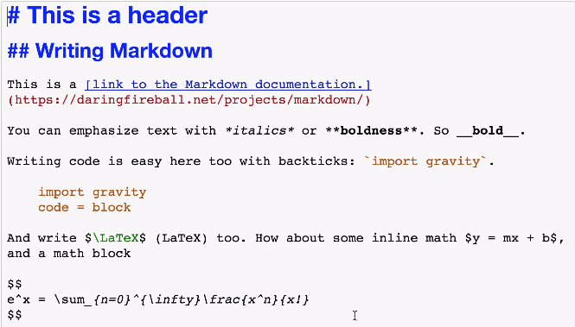

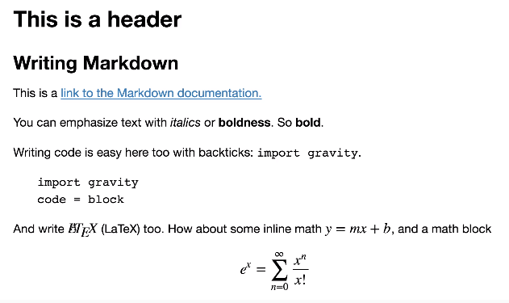

Since notebooks are JSON, it is simple to convert them to other formats. Jupyter comes with a utility called nbconvert for converting to HTML, Markdown, slideshows, etc.

For example, to convert a notebook to an HTML file, in your terminal use

jupyter nbconvert --to html notebook.ipynb

Converting to HTML is useful for sharing your notebooks with others who aren't using notebooks. Markdown is great for including a notebook in blogs and other text editors that accept Markdown formatting.

**[[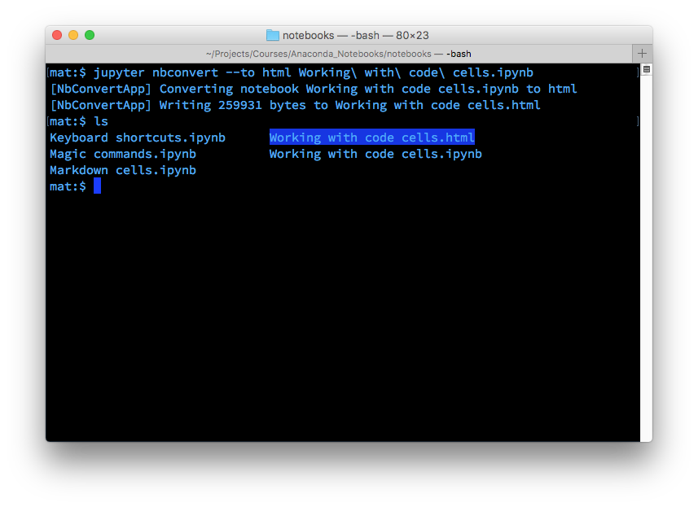](https://classroom.udacity.com/courses/ud1111/lessons/b15ba0a2-015d-4c5a-87ae-9efba2cabb43/concepts/2b324ee9-d6ec-4af4-b105-c4996b53d162)](https://classroom.udacity.com/courses/ud1111/lessons/b15ba0a2-015d-4c5a-87ae-9efba2cabb43/concepts/2b324ee9-d6ec-4af4-b105-c4996b53d162)**

Markdowns Link: <https://github.com/adam-p/markdown-here/wiki/Markdown-Cheatsheet>

slides

The slides are created in notebooks like normal, but you'll need to designate which cells are slides and the type of slide the cell will be. In the menu bar, click View > Cell Toolbar > Slideshow to bring up the slide cell menu on each cell.

